{Name of person you are requesting the donation from}
Address Line 1
Address Line 2
City, Province Postal Code

Date

Dear {name}

I’m participating in the 2024 Walk to Make Cystic Fibrosis History, on May 26, raising money to help make a difference in the lives of the over 4,300 Canadians living with cystic fibrosis (CF). All donations make a difference, and I would love to count on you to help me reach my fundraising goal.

Cystic Fibrosis Canada is a national not-for-profit organization and one of the world’s top three charitable organizations committed to improving and lengthening the lives of people living with cystic fibrosis (CF). In our 60-year history, we have advanced cystic fibrosis research and care that has more than doubled life expectancy for Canadians living with cystic fibrosis. CF is the most common, fatal genetic disease affecting young Canadians. It destroys the lungs and digestive system. There is no cure but investing in research over these past few years has made a huge difference in the lives of many Canadians.

The Walk To Make Cystic Fibrosis History has been our largest annual fundraising event for 20 years and this year, thousands of people across Canada will #StepToward ending CF for all. We want to raise as much as we can for research, advocacy, care, and support that will help people with CF live longer and healthier lives!

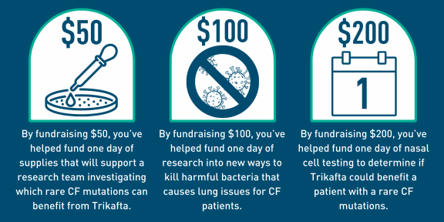
You can donate online on my fundraising page, {insert hyperlink to your fundraising page} or send a cheque using this pledge form, indicating my name. Please feel free to contact me by phone at {phone #} or by email at {email} if you have any questions or comments. You can also reach out to Cystic Fibrosis Canada directly at https://walk.cysticfibrosis.ca/ or walk@cysticfibrosis.ca to confirm this fundraiser.

Thank you in advance for your support.

Sincerely,

{Signature}

